Your Donation Saves Lives
Making a donation to the Friends of the Bedford Animal Shelter is one of the simplest things you can do to help prevent pet homelessness and save a life. Please consider donating to us.
Levels of Care for our Shelter Animals
- Level 1: $25.00 for heartworm tests, Flea/Tick Treatment or Microchip ID
- Level 2 : $35.00 for Vaccination package for a dog or a cat
- Level 3: $50.00 for spay/neutering for dog or a cat
- Level 4: $75.00 and up Sick/Injured animal fund
- Level 5: $325.00 for the all of the above package
INJURED ANIMAL FUND
Many of our animals have been abandoned due to the cost of veterinary care. This fund help ensure all animals rescued receive proper medical care while at the shelter.
SHELTER FUND/CAPITAL FUND
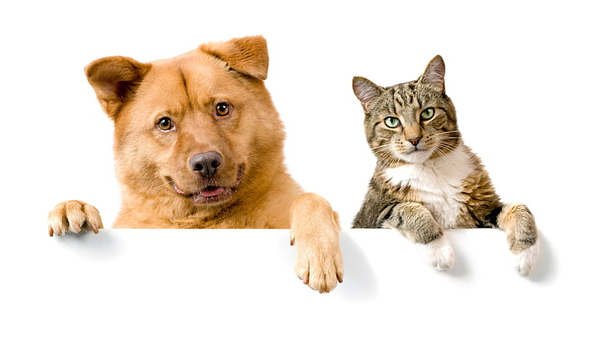
The Friends of the Bedford Animal Shelter is aware the need is great for a larger more up to date facility. Our facility was built in the 1970 ‘s when the city was much smaller.

